JANAVYUH
Sovereign Civic Intelligence & Public Investment Operating System
From Every Voice → Evidence → Simulation → Verified Impact
Unified master concept combining the strongest capabilities of
JANASYNTH and JANSETU-NEXUS, with additional next-level modules.
TRACK
Track 1 — AI for Digital Public Infrastructure & Governance
BRICS Theme: Innovation
Document status: Unified concept + technical blueprint + MVP plan

Team: [Your team name]
Version 1.0 | Detailed proposal / whitepaper draft

Executive Snapshot
JANAVYUH is a proposed multilingual, privacy-aware civic intelligence and public-investment operating system. It sits above fragmented citizen-feedback channels, public datasets, infrastructure registries and investment systems. Its job is to convert lived experience into structured evidence, discover gaps that ordinary complaint counts miss, connect needs to actual infrastructure assets and dependencies, forecast future pressure, simulate competing investment choices, support transparent human decisions, and verify post-project outcomes.
Capability | What JANAVYUH does | Primary value
Hear | Voice, WhatsApp, IVR, SMS, USSD, kiosks, offline-assisted input | Universal access
Understand | ASR, language identification, semantic extraction, code-switch handling | Natural-language civic intelligence
Connect | Need Graph + Infrastructure Asset Graph | Root-cause and dependency reasoning
Discover | Hotspots, silent zones, anomalies, hidden needs | Anti-bias + early warning
Predict | Future demand and infrastructure stress | Preventive planning
Simulate | Counterfactual project and budget scenarios | Evidence before commitment
Negotiate | Multi-agent analytical debate | Visible trade-offs
Govern | Publicly configurable fairness parameter | Transparent policy weighting
Prove | Evidence-backed impact verification | Outcome accountability
Learn | Calibration from measured outcomes | Continuous improvement
Federate | Sovereign national nodes + optional federated learning | BRICS-scale collaboration

CORE POSITIONING
JANAVYUH is not a complaint portal and not an autonomous spending authority. It is a decision-support and public-service intelligence layer that organizes evidence, simulations and verification so authorized institutions can make accountable decisions.

Contents
- 1. Concept and Vision
- 2. Challenge Alignment and Problem Deconstruction
- 3. Product Principles and Operating Model
- 4. End-to-End Architecture
- 5. JANASRUTI: Universal Citizen Signal Layer
- 6. RAKSHAK: Privacy, Identity and Anti-Abuse
- 7. MANTHAN: Neuro-Symbolic Understanding
- 8. JANAGRAPH: Civic Need + Infrastructure Asset Graph
- 9. CIVIC TWIN: Living Regional State Model
- 10. Discovery Intelligence
- 11. Causal Mesh and Dependency Intelligence
- 12. NIRNAY: Multi-Agent Policy Arena
- 13. JANMAT: Participatory Fairness Governance
- 14. Policy Time Machine and Counterfactual Lab
- 15. Budget Portfolio Engine
- 16. Project Pre-Mortem and Readiness
- 17. SETU: Policy Copilot and Evidence Bridge
- 18. PRAMAN: Impact Verification and Impact Receipts
- 19. UTTAR: Citizen Trust and Impact Credential
- 20. SANGAM: Sovereign BRICS Federation
- 21. Data Strategy and BRICS Civic Ontology
- 22. AI/ML Technical Design
- 23. Data Model and APIs
- 24. Security, Governance and Responsible AI
- 25. Deployment and MLOps
- 26. User Roles and UX
- 27. Hackathon MVP
- 28. Four-Minute Demo
- 29. KPIs and Evaluation
- 30. Risks and Mitigations
- 31. Roadmap and Sustainability
- 32. Differentiation and Novelty Positioning
- 33. Judge Q&A
- Appendices

1. Concept and Vision
The combined design starts from a simple observation: a citizen request is valuable only when the system can understand what the person means, connect it to measurable conditions, compare it with competing needs, and later determine whether the public intervention worked. JANAVYUH therefore treats citizen input as evidence in a larger decision system rather than as a ticket that ends at routing or closure.

1.1 Vision
Every citizen voice can become a structured, privacy-aware and evidence-backed input into public planning, while every funded intervention can be traced forward to implementation and measured outcomes.

1.2 The master loop
HEAR → UNDERSTAND → CONNECT → DISCOVER → PREDICT → SIMULATE → NEGOTIATE → GOVERN → ACT → PROVE → LEARN.
The key system-level innovation is the feedback connection from measured outcomes back into future planning models. This turns a static analytics product into a learning operating loop.
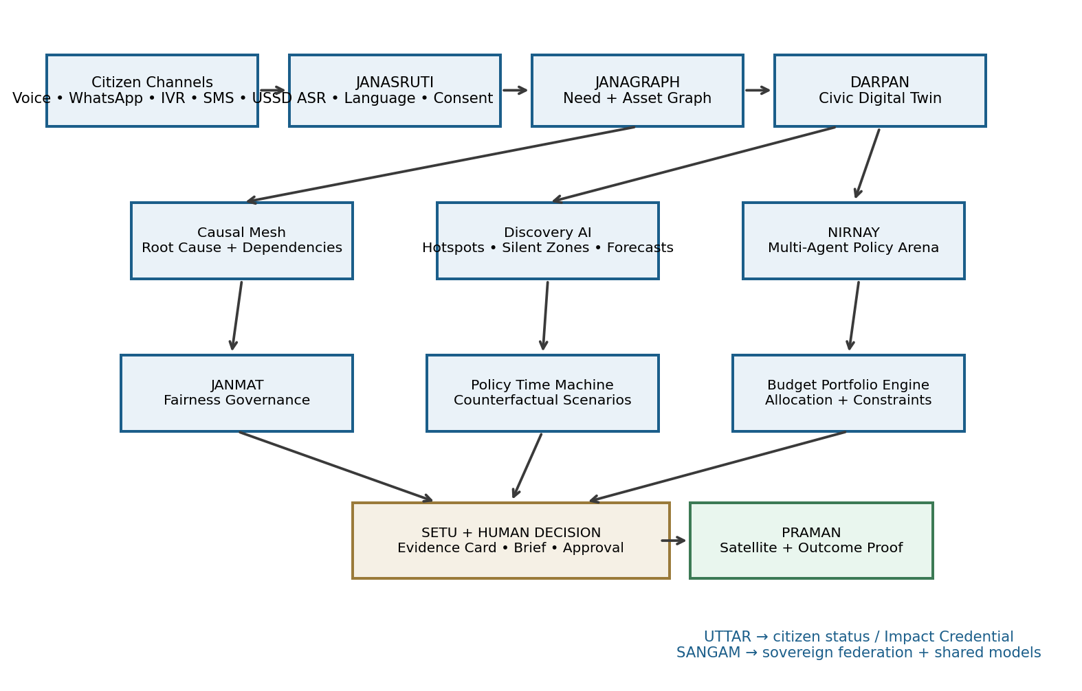
Figure 1. JANAVYUH master architecture: citizen access, semantic intelligence, graphs, twin, discovery, negotiation, simulation, human decision and impact proof.
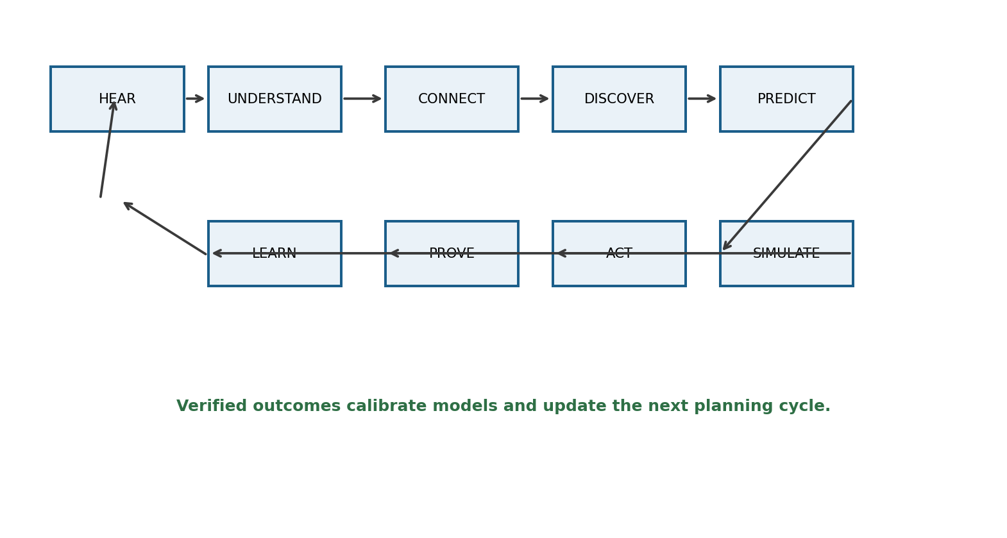
Figure 2. Closed-loop operating model: verified outcomes become evidence for the next planning cycle.

2. Challenge Alignment and Problem Deconstruction
The supplied challenge asks for a scalable multilingual AI platform that can aggregate citizen development requests through voice, text and messaging applications; combine citizen feedback with demographic data, infrastructure indices and public investment plans; surface demand hotspots; and recommend high-priority development projects across BRICS nations.
Challenge need | JANAVYUH response | Demo proof
Fragmented input | Channel adapters + common CivicSignal schema | One voice request becomes one structured record
Multilingual / diverse regions | Language ID + ASR + semantic normalization + locale adapters | Same need in two languages maps to one civic need
Heterogeneous datasets | Unified data fabric for signals, demographics, infrastructure, budgets, geography | Recommendation card cites multiple evidence classes
Demand hotspots | Semantic + spatial clustering and service-gap overlays | Map shows hotspot + measured deficit
High-priority projects | Transparent multi-factor engine + agent analysis + scenario simulation | Why-this card + alternative interventions
Impact measurement | Baseline/follow-up + evidence chain + Impact Receipt | Completed project receives an evidence-backed scorecard
BRICS scalability | Country adapters + sovereign nodes + federated learning option | Architecture shows local data boundaries

2.1 Three primary failures
Failure | Why basic systems struggle | JANAVYUH mechanism
Unified demand signal is missing | Inputs are scattered and reporting capacity is unequal | Multimodal ingestion, semantic clustering, denominator-aware rates, silent-zone detector
Prioritization is weak | Complaint volume can confuse popularity with need | Infrastructure gap + exposure + future risk + dependencies + scenario simulation
Impact loop is missing | Completion status does not prove outcome improvement | Baseline/follow-up + outcome measurement + evidence receipt

2.2 Why complaint counting is insufficient
A high complaint count can indicate severe need, but it can also reflect high awareness or easy digital access. Conversely, a region with weak connectivity or low reporting confidence can appear artificially quiet. JANAVYUH therefore separates reported demand, measured service deficit and predicted future need.
Signal | What it tells the model | Limitation when isolated
Citizen signals | Lived experience and service friction | May be duplicated, incomplete or unevenly distributed
Infrastructure indicators | Capacity, coverage and condition | May lag user experience or omit emerging stress
Demographic context | Who may be exposed and at what scale | Does not itself establish an intervention
Investment data | What has already been funded | Funding does not guarantee outcomes
Outcome signals | What changed after intervention | Arrives later and needs attribution

3. Product Principles and Operating Model
- Voice-first and low-literacy capable: a citizen should not need to learn government vocabulary to participate.
- Equity as an explicit model parameter: reporting bias should be measured rather than assumed away.
- Data sovereignty: national nodes can retain raw citizen data inside jurisdictional boundaries.
- Privacy by minimization and aggregation: public surfaces never need individual-level exposure.
- Evidence before confidence: outputs carry source, timestamp, model version and uncertainty.
- Human approval at consequential decision points: AI provides analysis, not autonomous public spending authority.
- Operational realism: candidate interventions include cost, dependencies, readiness and failure modes.
- Open interfaces and country adapters: the reasoning layer should be portable across BRICS administrative systems.

3.1 Success is defined as a closed decision loop
A signal is not the final product. The product outcome is a traceable chain: signal → underlying need → evidence context → scenario → human decision → implementation → measured result → learning signal.

3.2 Core users
User | Primary need
Citizen | Submit a problem naturally, understand status, see community-level outcome
District/local officer | Find hotspots, inspect evidence, compare interventions, track outcomes
Planner / policy analyst | Explore portfolios, future demand and budget scenarios
Auditor / transparency team | Reconstruct why a decision happened and inspect outcome evidence
Researcher / public observer | Use aggregate data, provenance and model documentation
Frontline worker | Collect assisted/offline signals from communities without full digital access

4. End-to-End Architecture
JANAVYUH uses a layered architecture so the citizen interface, AI models, graph layer, simulation services, proof system and national federation can evolve independently. The layers produce versioned artifacts and auditable events.
Layer | Module | Technical responsibility | Primary output
L0 | Access Mesh | WhatsApp/IVR/SMS/USSD/web/kiosk/offline adapters | Raw channel event + consent metadata
L1 | JANASRUTI | Language ID, ASR, translation, code-switch handling | Transcript + normalized civic text
L2 | JANAGRAPH | Civic Need Graph + infrastructure asset graph | Linked evidence graph
L3 | CIVIC TWIN | PostGIS + graph + time-aware state | Current regional state
L4 | Causal Mesh | Root-cause, dependencies, exposure and causal context | Dependency/causal context
L5 | Discovery AI | Hotspots, silent zones, anomalies, forecasting | Need forecasts + alerts
L6 | NIRNAY | Multi-agent analytical negotiation | Alternative assessments
L7 | Simulation & Portfolio | Counterfactual scenarios, budget allocator, portfolio optimizer | Scenario comparison
L8 | Human Decision Bridge | Evidence cards, policy briefs, approvals, audit workflow | Decision package + audit event
L9 | PRAMAN + Learning | Outcome evidence, Impact Receipt, calibration | Verified impact + learning signal

4.1 Event-driven architecture
CitizenSignalCreated → SignalNormalized → NeedClusterUpdated → TwinUpdated
→ ForecastUpdated → ScenarioGenerated → DecisionRecorded → ProjectUpdated
→ OutcomeMeasured → ImpactReceiptPublished → ModelCalibrationQueued
Every event should carry event_id, timestamp, jurisdiction, actor/service, object_id, model_version when applicable, source references and a correlation_id so a complete decision chain can be reconstructed.

4.2 Non-functional requirements
Requirement | Design target
Availability | Graceful degradation: asynchronous queues and cached maps
Latency | Citizen acknowledgement seconds; structured analysis within minutes for MVP
Scalability | Stateless APIs + event queues + partitioned geospatial data
Privacy | Separate operational identity from analytical identifiers
Auditability | Immutable/append-only decision and evidence history
Explainability | Evidence contribution + assumption + confidence for important outputs
Localization | Country adapters and locale-specific model configuration
Resilience | Offline queueing at edge for low-connectivity workflows

5. JANASRUTI — Universal Citizen Signal Layer
JANASRUTI is designed around how citizens actually communicate. It supports natural voice or text and avoids assuming smartphone ownership, high literacy or permanent connectivity.
Channel | User experience | Technology | Priority
WhatsApp | Voice note / text | Business API + object store + webhook | High
IVR / missed call | Call and speak naturally | Asterisk / Twilio / Exotel-style flow | High
SMS | Short request | SMS gateway webhook | Medium
USSD | Feature-phone menu | USSD gateway | Stretch / pilot
Web / PWA | Text + voice capture | Next.js / React | High
Assisted kiosk | Frontline worker records issue | Kiosk mode + consent workflow | High
Offline mobile unit | Local capture, later sync | Encrypted queue + sync service | Future
Community radio bridge | Operator-assisted call capture | Call-in operator workflow | Future

5.1 Multilingual pipeline
- Receive audio/text and capture channel metadata.
- Detect language and likely code-switching.
- Run ASR if the source is voice.
- Normalize spelling, script variation and local expressions.
- Translate only when a downstream model requires a pivot representation.
- Extract issue, service, asset, place, urgency, timeframe and affected context.
- Ask the citizen to confirm ambiguous interpretations.
- Store provenance and model version with the structured signal.

5.2 Zero-literacy workflow
A citizen can speak, listen to the system confirm the interpreted issue, receive a reference identifier, and later hear status updates. The voice experience should be short, predictable and resumable after connectivity interruptions.

5.3 Technical pipeline
Component | Possible implementation | Input | Output | Main challenge
ASR | Whisper-class / local speech model | Audio | Transcript | Noise, dialect, code-switching
Language ID | Transformer / fast classifier | Audio/text | Language + confidence | Mixed languages
Semantic encoder | Multilingual sentence embeddings | Normalized text | Vector | Cross-language similarity
Intent classifier | Multilingual transformer / constrained LLM | Text + context | Category + confidence | Rare classes
Entity extraction | LLM structured output + rules | Text | Place, asset, service, time | Hallucinated entities
Urgency classifier | Calibrated classifier / LLM | Text + metadata | Urgency + confidence | Subjective wording
Geocoder | Gazetteer + PostGIS | Place name / GPS | Geometry + resolution confidence | Ambiguous names

6. RAKSHAK — Privacy, Identity and Anti-Abuse
RAKSHAK combines data minimization, consent, operational rate limits and optional privacy-preserving eligibility credentials. The technical objective is not “maximum identity data”; it is enough assurance to protect service quality while reducing unnecessary collection.

6.1 Privacy architecture
Control | Implementation concept
Data minimization | Store only fields required for the declared purpose
Purpose binding | Separate service-handling consent from optional analytics consent
Identity separation | Keep operational identity in a restricted service boundary
Public aggregation | Publish cluster-level statistics; suppress small cells
Encryption | TLS in transit and envelope encryption at rest
Access control | Role-based access + least privilege
Retention | Policy-defined retention and deletion schedules
Audit trail | Log access and high-impact administrative actions

6.2 Optional zero-knowledge eligibility
A production deployment may use verifiable credentials and a zero-knowledge proof so a trusted issuer can attest to a property such as regional eligibility without exposing the underlying credential. For the MVP, synthetic credentials or OTP/device rate limiting are sufficient.

6.3 Anti-abuse intelligence
- Burst detection on sudden cluster growth.
- Coordinated-language similarity checks for manufactured campaigns.
- Device/channel rate limits.
- Source-aware weighting rather than automatic deletion.
- Human review for suspicious clusters before they affect high-impact decisions.

7. MANTHAN — Neuro-Symbolic Understanding
MANTHAN is the semantic engine. It uses neural language models to understand natural language and a symbolic civic ontology/graph to constrain what the extracted information means in context.

7.1 Neural + symbolic roles
Layer | Role
Neural | Speech recognition, language understanding, semantic similarity, entity extraction
Symbolic | Ontology mapping, valid category hierarchy, infrastructure relationships, location context
Constraint layer | Schema validation, required-field checks, allowable relations, confidence thresholds
Human layer | Confirmation queue for low-confidence interpretation

7.2 Example
Citizen message: “There is no bus after 7 PM near our college.” MANTHAN extracts a late-evening transport need, a place context, likely affected students/commuters, related route/road assets, and a time-of-day constraint. JANAGRAPH then connects these entities to existing infrastructure and projects.

7.3 Structural validation
A request should be checked not only for semantic meaning but for structural context. For example, if a citizen asks for a service expansion, the graph can reveal nearby capacity, existing projects, dependencies and current coverage before presenting a recommendation.

8. JANAGRAPH — Civic Need + Infrastructure Asset Graph
JANAGRAPH is the semantic backbone. A citizen signal is connected to the place, need, asset, service, population context, project and outcome instead of remaining an isolated ticket.
Node | Representative attributes | Relationships
CitizenSignal | language, source, timestamp, geo, urgency, confidence | reported_at, similar_to, mentions
CivicNeed | category, severity, evidence_count, confidence, trend | affects_service, occurs_in, related_to
Place | village/ward/district, geometry, hierarchy | contains, adjacent_to, served_by
InfrastructureAsset | type, capacity, condition, availability | located_in, serves, constrained_by
Service | water, transport, health, education, connectivity | delivered_by, measured_by
PopulationContext | population, access proxies, segments | present_in, exposed_to
Project | budget, status, timeline, intervention type | targets_need, funded_by, implemented_in
OutcomeMetric | baseline, follow-up, source, date | result_of, validates

8.1 Duplicate Problem Fusion
similarity(i,j) = cosine(embedding_i, embedding_j)
cluster = semantic_similarity + spatial_proximity + temporal_window
cluster_weight = Σ(confidence × recency_weight × source_weight)
The principle is “merge analytically, preserve evidentially.” Similar reports become one underlying issue for planning, while each original submission remains traceable as evidence.

8.2 Infrastructure Dependency Graph
A project can have prerequisite relationships. A health facility may require road access, electricity, water, digital connectivity, workforce capacity and ambulance reach. The graph explicitly represents these dependencies so a standalone intervention is not mistaken for a complete solution.

9. CIVIC TWIN — Living Regional State Model
The Civic Digital Twin is a policy-intelligence representation of a region over time. It is not required to be a photorealistic 3D replica. The twin maintains relationships between people, needs, places, services, assets, projects, investments, outcomes and time.
Twin dimension | Representative state | Update cadence
People/context | Population, service-user segments, accessibility proxies | Quarterly/annual
Needs | Clusters, intensity, trend, confidence | Daily/weekly
Places | Boundaries, routes, service catchments | As source datasets change
Services | Coverage, reliability, access thresholds | Daily/monthly
Infrastructure | Asset location, capacity, condition, coverage | As asset data changes
Projects | Proposed/approved/active/completed, cost, timeline | Event-driven
Outcomes | Baseline, follow-up, citizen feedback, observed change | Measurement schedule
Time | Historical snapshots + current state + forecasts | Continuous

9.1 Twin query questions
- What is true now?
- What is changing?
- What may happen next?
- What depends on what?
- What changed after an intervention?

10. Discovery Intelligence — Hotspots, Silent Zones, Anomalies and Forecasts

10.1 Dynamic hotspot detection
Hotspot detection combines semantic similarity with geography. A cluster should represent a coherent issue in a spatial context, not merely a visually dense map.
Practical MVP: sentence embeddings → HDBSCAN → geospatial filtering → temporal decay
Advanced: joint semantic-spatial clustering with population-normalised intensity.

10.2 Silent-Zone detector
The detector compares observed reporting activity with expected reporting capacity using demographic/connectivity context. A statistically quiet area with a high measured infrastructure deficit is flagged for proactive outreach.

10.3 Civic anomaly radar
A rolling baseline or Isolation Forest-style detector can identify unusual increases in service-gap signals, infrastructure incidents or citizen reports. Alerts should be treated as triage signals, not automatic declarations of an emergency.

10.4 Future need forecasting
The MVP can use transparent time-series baselines or gradient-boosted models. Later versions can introduce spatiotemporal graph neural networks that incorporate geography and infrastructure relationships. Forecasts must expose horizon, training window, confidence and known data gaps.

11. Causal Mesh and Dependency Intelligence
JANAVYUH distinguishes association from causal evidence. The Causal Mesh records hypothesized pathways from an intervention to measurable outcomes and identifies prerequisite dependencies.

11.1 Causal reasoning workflow
- Define intervention and target outcome.
- Identify observable confounders and comparable locations where possible.
- Build a baseline and follow-up measurement plan.
- Use matched-area or difference-in-differences-ready structures when data permits.
- Produce an estimated effect range rather than a single certainty claim.
- Compare estimated effects against the post-project measurement.
- Log model version, assumptions and evidence quality.

11.2 Dependency readiness score
Dimension | Example question | Output
Access | Can the target population physically reach the intervention? | Access readiness
Utilities | Are power/water/connectivity prerequisites available? | Dependency gap
Operational | Is staffing or maintenance capacity present? | Operational readiness
Financial | Is lifecycle funding realistic, not just capex? | Lifecycle risk
Institutional | Is there a responsible authority and workflow? | Ownership readiness

12. NIRNAY — Multi-Agent Policy Arena
NIRNAY is the load-bearing decision-support module. Instead of hiding all trade-offs inside one score, specialized analytical agents inspect the same evidence from different objectives and produce a transparent synthesis.
Agent | Question it asks | Typical evidence
Equity Advocate | Who is underserved or underrepresented? | Silent zones, deprivation and access gaps
Impact Optimizer | Which intervention has the strongest expected outcome per lifecycle cost? | Scenario outputs, outcome models
Budget Constraint Agent | What remains feasible under the fiscal envelope? | Budget, commitments, unit costs
Resilience Guardian | Which option reduces measured climate/disaster exposure? | Hazard and vulnerability layers
Infrastructure Guardian | Will dependencies allow this project to work? | Asset graph and readiness
Evidence Auditor | What is actually supported by the available evidence? | Provenance, confidence, freshness

12.1 Agent protocol
1. Retrieve approved evidence bundle from DARPAN/JANAGRAPH.
2. Each agent produces: claim, evidence refs, assumptions, uncertainty, counter-argument.
3. Orchestrator checks unsupported claims.
4. Synthesis agent produces options, trade-offs and unresolved questions.
5. Human decision-maker reviews and records final action.
The system should publish a concise debate summary rather than expose unrestricted internal chain-of-thought. The public-facing record should contain evidence-backed claims, arguments, counter-arguments and final rationale, not hidden model reasoning traces.

12.2 Cross-department conflict resolution
The same framework can structure cases where departments request overlapping resources. For example, water and roads may compete for a constrained regional allocation. NIRNAY can model the shared budget constraint, dependencies and outcome coverage across both portfolios.

13. JANMAT — Participatory Fairness Governance
JANMAT makes an important governance parameter explicit: the balance between equity and efficiency. Instead of hiding that choice inside code, the system can periodically collect bounded public input through low-bandwidth channels and log the resulting parameter update under governance rules.

13.1 Fairness parameter
Score(p) = w1·DemandIntensity
+ w2·EquityContext(α)
+ w3·GapSeverity
+ w4·CausalCostEffectiveness
+ w5·ResilienceCoBenefit
+ w6·Readiness
− w7·DuplicationRisk
− w8·UncertaintyPenalty
Here α is an equity-appetite parameter, not a direct ranking decision. Any public participation mechanism must have clear eligibility, anti-abuse, aggregation, audit and governance rules. A citizen vote should influence a published policy parameter, not silently select individual projects.

13.2 JANMAT workflow
- Publish the current fairness configuration and explanation.
- Collect bounded low-bandwidth responses.
- Apply eligibility/rate controls.
- Aggregate responses using documented rules.
- Calculate proposed parameter delta.
- Human stewardship reviews the cycle.
- Record the approved parameter version and effective date.

14. Policy Time Machine and Counterfactual Lab
The Policy Time Machine gives planners three perspectives: what happened before, what the civic state looks like now, and what may happen under alternative intervention assumptions.
View | Question | Example
Past | What happened under similar interventions? | Similar route upgrades in matched areas
Present | What is the current state? | Coverage, demand, infrastructure condition
Future | What may happen without intervention? | Forecasted demand pressure
Counterfactual A | What if we fund option A? | New bus route
Counterfactual B | What if we fund option B? | Route + road package
Counterfactual C | What if the budget is reduced? | Lower capex / phased deployment

14.1 Scenario output contract
- Population/households reached
- Expected service-gap reduction
- Coverage change
- Expected residual demand
- Budget utilization
- Lifecycle cost
- Confidence interval
- Key assumptions
- Sensitivity of result to uncertain inputs

15. Budget Portfolio Engine
The engine optimizes not only individual projects but potentially a portfolio under a constrained budget. It should make trade-offs explicit rather than hiding them.
Scenario | Illustrative allocation | Question
A — Transport first | ₹5 Cr buses + ₹3 Cr route improvements + ₹2 Cr access roads | How much mobility access improves?
B — Access first | ₹3 Cr buses + ₹5 Cr route improvements + ₹2 Cr targeted roads | Does service redesign outperform fleet-heavy investment?
C — Balanced | ₹3.5 Cr + ₹3.5 Cr + ₹3 Cr | What are the cross-indicator trade-offs?

15.1 Portfolio constraints
- Total budget constraint
- Departmental minimums/maximums
- Existing commitments
- Lifecycle operation and maintenance
- Dependency prerequisites
- Geographic coverage constraints
- Equity guardrails
- Maximum acceptable uncertainty

15.2 Portfolio objective example
maximize Σ Impact(project_i)
subject to Σ Cost(project_i) ≤ Budget
DependencyReadiness(project_i) ≥ threshold
CoverageEquityGap ≤ policy_limit
ExistingCommitments preserved

16. Project Pre-Mortem and Readiness
Before a project reaches the human approval stage, JANAVYUH can ask: “Assume the intervention failed. What plausible reasons exist?” The goal is to surface dependencies and implementation risks before funding is finalized.
Risk class | Example warning | Possible mitigation
Access | Target population may not reach facility | Route/access project bundled first
Utility | Power or water dependency incomplete | Stage prerequisites before service launch
Capacity | Staffing below service requirement | Operational plan / staffing commitment
Maintenance | Lifecycle resources unspecified | O&M budget and authority assignment
Data | Outcome measurement unavailable | Define baseline and data owner before approval

17. SETU — Policy Copilot and Evidence Bridge
SETU transforms an approved scenario and evidence bundle into a human-readable decision package. It uses retrieval-augmented generation over approved government documents and project metadata rather than asking a general LLM to invent policy content.

17.1 RAG architecture
Approved sources → document ingestion → chunking → embeddings → metadata filters
→ jurisdiction / date / authority retrieval → grounded generation → provenance citations
→ human review → export / integration
Output | Purpose
Evidence Card | Why this option is being considered
Policy Brief | Problem, evidence, options, uncertainty, decision request
Budget Memo | Allocation, assumptions, residual gap, fiscal notes
Tender Scope Draft | Structured scope outline for human procurement review
Public Summary | Plain-language explanation for citizens/public observers

18. PRAMAN — Impact Verification and Impact Receipts
PRAMAN separates project completion from project effectiveness. It creates a baseline, records the intervention, collects follow-up evidence, and packages the result into a verifiable receipt.

18.1 Evidence sources
Evidence | Use
Administrative data | Official service metrics and project records
Satellite / earth observation | Selected physical change indicators
Citizen photos | Geofenced/validated local evidence
IoT/service sensors | Reliability and capacity indicators where available
Citizen follow-up | Lived experience after intervention
Matched-area / quasi-experimental analysis | Stronger attribution where data permits

18.2 Impact Receipt schema
{
"receipt_id": "IR-2026-0042",
"project_id": "prj_88",
"predicted": {"beneficiaries": 4820},
"measured": {"beneficiaries": 4610, "confidence": 0.87},
"evidence_refs": ["admin:...", "eo:...", "citizen:..."],
"model_version": "sim-v3",
"merkle_root": "0x...",
"published_at": "..."
}

18.3 Verification score
A composite score can combine evidence completeness, source reliability, geospatial consistency, measurement consistency and outcome-model alignment. The score should be interpreted as an evidence-quality indicator, not as a statement that the project caused every observed change.

19. UTTAR — Citizen Trust and Impact Credential
UTTAR is the citizen-facing loop. A report should not disappear after submission. The system can provide a status timeline in the citizen’s language.
Received → Understood → Clustered → Debated → Prioritised → Approved → Built → Verified

19.1 Impact Credential
After verification, an optional signed credential can communicate that the citizen contribution was part of a funded and verified project outcome. It should not be sold, tokenized or used as a speculative asset.

20. SANGAM — Sovereign BRICS Federation
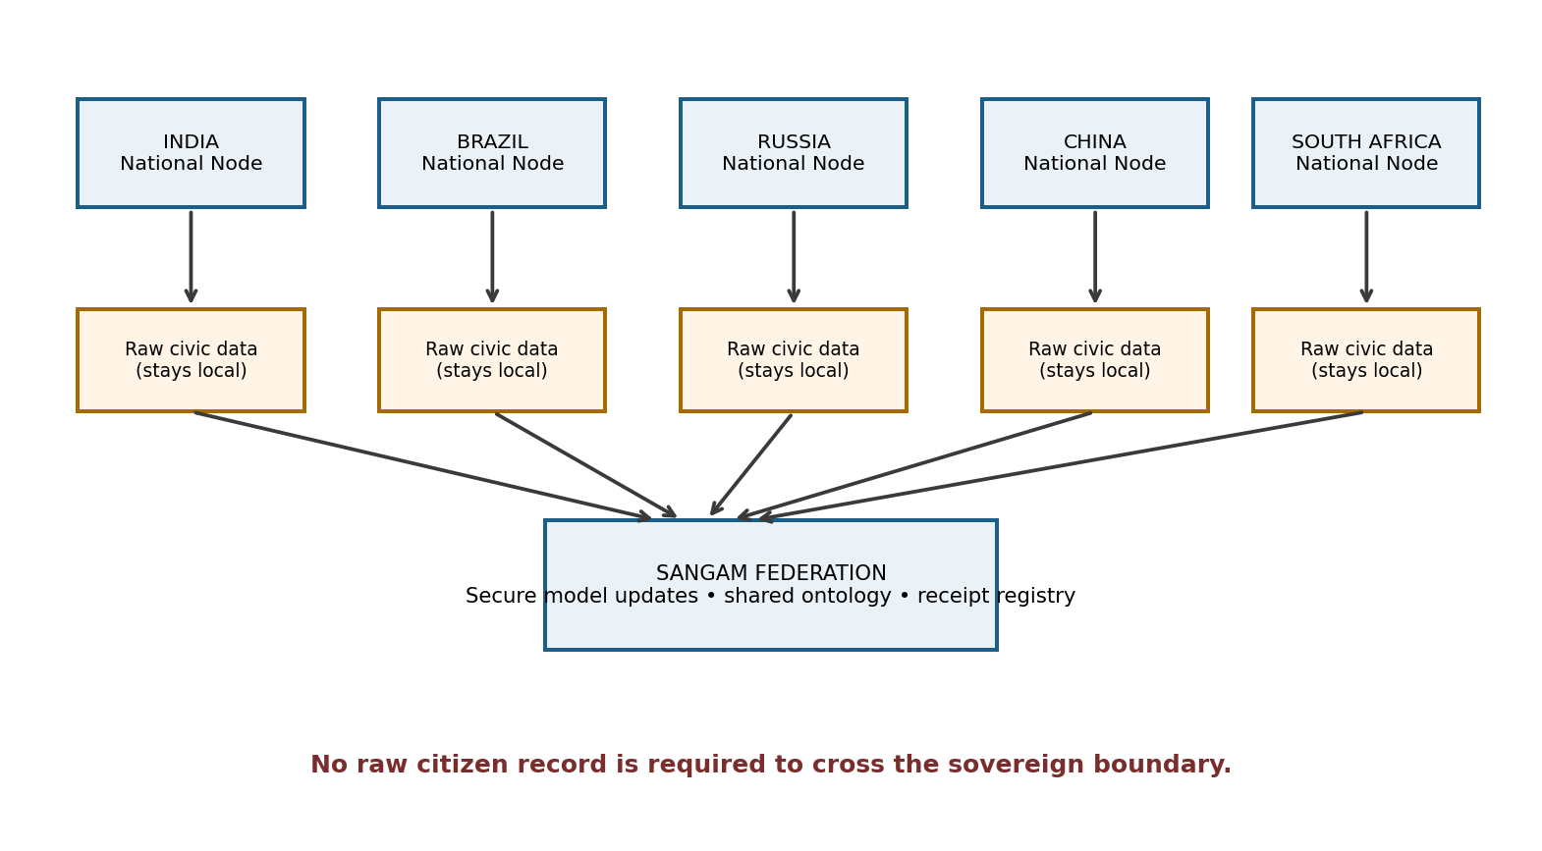
Figure 3. Sovereign federation model: raw citizen data remains in national nodes while approved model updates and shared metadata can travel.
SANGAM lets each country host its own full stack while sharing selected model updates, ontology definitions, evaluation artifacts and public receipt metadata. The purpose is not to centralize raw citizen records but to support collaborative learning across jurisdictions.
Dimension | Design
Data boundary | Citizen data stays in national node
Shared asset | Ontology registry, model registry, approved metrics and public receipts
Learning | Optional federated model updates using secure aggregation
Governance | Country-level authorities retain decision control
Interoperability | Country-specific adapters for language, taxonomy and administrative hierarchy

21. Data Strategy and BRICS Civic Ontology
A shared ontology gives the system a common conceptual language while allowing national extensions. Example domains include water, sanitation, roads and mobility, energy, health, education, housing, connectivity and climate resilience.
Data domain | MVP strategy | Use
Citizen feedback | Synthetic multilingual data + demo forms + optional recordings | Intent extraction, clustering, demand intensity
Geospatial | OpenStreetMap or equivalent | Routes, service locations, access
Demographics | Public statistics or synthetic profiles | Exposure and denominator-aware analysis
Infrastructure | Open municipal datasets or structured demo data | Coverage, capacity, condition
Public investment | Open project/budget lists or synthetic portfolio | Current commitments, scenarios
Outcomes | Synthetic/available time series | Impact verification and calibration

21.1 Data quality controls
- Source + timestamp + publisher/connector provenance
- Duplicate management with evidence preservation
- Missingness indicators
- Population denominator checks
- Temporal validity checks
- Confidence tagging
- Model/data versioning

22. AI/ML Technical Design

22.1 Model routing strategy
JANAVYUH should not use the largest model for every task. Small deterministic or specialized models can handle routing, language identification, anomaly detection and schema checks, while an LLM is reserved for semantic extraction, grounded explanation and policy drafting.
AI task | MVP approach | Advanced approach | Output
Speech recognition | Whisper-class | Language-cluster fine-tunes | Transcript + confidence
Language ID | Fast transformer/classifier | Locale-adaptive model | Language + probability
Intent extraction | Constrained LLM | Fine-tuned multilingual model | Category/subcategory
Semantic clustering | Sentence embeddings + HDBSCAN | Joint graph clustering | Underlying needs
Anomaly detection | Rolling z-score / Isolation Forest | Graph-aware anomaly model | Alert
Forecasting | Prophet/XGBoost-style features | ST-GNN | Future pressure estimate
Recommendation | Weighted evidence model | Constrained ML + causal model | Candidate interventions
Scenario simulation | Response curves | Surrogate causal/ML ensemble | Impact vector + CI
Explanation | Template + RAG | Grounded LLM | Evidence rationale

22.2 Confidence and uncertainty
Each important model output should expose a confidence measure or uncertainty interval. The UI should show when sparse data, outdated indicators or weakly validated models are driving the result.

22.3 Human-in-the-loop thresholds
Condition | System action
High confidence / low consequence | Automated normalization permitted
Low confidence interpretation | Ask citizen or operator for confirmation
High-impact recommendation | Mandatory evidence review
Scenario with material uncertainty | Highlight assumptions and confidence range
Sensitive or anomalous pattern | Human review before escalation

23. Data Model and APIs

23.1 Core entities
Entity | Key fields
CitizenSignal | signal_id, channel, language, transcript_ref, timestamp, geometry, consent_scope
CivicNeed | need_id, category, severity, cluster_id, evidence_count, confidence, trend
InfrastructureAsset | asset_id, type, capacity, condition, service_area
Project | project_id, intervention_type, budget, status, target_need_id
Scenario | scenario_id, budget, allocation_vector, assumptions, model_version
OutcomeMetric | metric_id, project_id, baseline, followup, source, date
AuditEvent | event_id, actor_role, action, object_id, timestamp, metadata
ImpactReceipt | receipt_id, project_id, predicted, measured, evidence_refs, merkle_root

23.2 Core APIs
POST /signals/ingest
GET /signals?bbox=&category=&since=
POST /signals/{id}/analyze
GET /needs?place=...
POST /clusters/recompute
GET /hotspots?jurisdiction=...
POST /forecast
POST /negotiate {competingCards[]}
POST /simulate {projectCard, budget, assumptions}
POST /briefs/generate {priorityId, languages[]}
POST /janmat/vote
POST /verify/evidence
GET /receipts/{id}
GET /track/{signalId}

23.3 Example CivicSignal
{
"signal_id": "sig_01",
"channel": "whatsapp_voice",
"language": "ta",
"intent": {"category": "public_transport", "urgency": "medium", "confidence": 0.94},
"geo": {"ward": "W-12", "lat": 13.00, "lon": 80.25},
"consent": true,
"model_version": "manthan-v2"
}

24. Security, Governance and Responsible AI
Area | Control
Privacy | Minimization, consent, aggregation, encryption, role separation
Security | Secure APIs, secrets management, rate limiting, logging
Model governance | Model cards, evaluation sets, monitoring, rollback
Bias monitoring | Language, geography, connectivity and reporting-channel comparisons
Auditability | Versioned weights, evidence references, decision events
Human control | Explicit approval gate for consequential recommendations
Public transparency | Aggregate outputs, methodology, model limitations and receipt verification
Political neutrality | No campaign targeting, persuasion, demographic political profiling or automated political decisions

24.1 Important governance rule
JANAVYUH should never infer political preference from civic feedback. A request such as “we need a road” is treated as a service need, not as evidence of political identity or voting behavior.

25. Deployment and MLOps
Layer | Technology options | Reason
Frontend | Next.js / React + Tailwind | Fast dashboard development
Maps | MapLibre / deck.gl / Leaflet | Interactive geospatial analysis
API | FastAPI | Typed Python services
Data | PostgreSQL + PostGIS | Relational + spatial queries
Graph | Neo4j | Relationship-heavy reasoning
Vector | pgvector / vector DB | Semantic retrieval
Queue | Redis / Kafka-style bus | Asynchronous processing
ML | Python + PyTorch | Model services
Earth observation | Google Earth Engine / satellite APIs | Selected verification workflows
Federated learning | Flower / NVIDIA FLARE | Cross-node model updates
Ledger | Hyperledger Fabric or tamper-evident log | Receipt/audit integrity
Deployment | Docker + Kubernetes | Portable, scalable services
Observability | OpenTelemetry | System and model monitoring

25.1 Environment topology
Internet/telephony → API Gateway → channel service → event queue
↓
region/country processing cluster
↓
PostGIS + Neo4j + vector store + model endpoints
↓
decision services + evidence/receipt store
↓
dashboard + public explorer

26. User Roles and UX

26.1 Citizen journey
- Speak/type naturally.
- Receive a language-specific confirmation.
- Confirm location/context when required.
- Get a reference ID.
- Receive status updates on the same channel.
- Receive community-level impact information where appropriate.

26.2 Policymaker journey
- Select region and sector.
- Inspect demand + service gap + investment context.
- Open a hotspot and inspect JANAGRAPH evidence.
- Review future forecasts and dependency readiness.
- Open NIRNAY agent perspectives.
- Test policy/budget scenarios.
- Review SETU evidence card.
- Record human approval and rationale.
- Track PRAMAN outcome evidence.

26.3 Auditor journey
The auditor reconstructs source data, timestamps, model versions, factor contributions, scenario assumptions, human approval events and measured outcomes.

27. Hackathon MVP
MVP PRINCIPLE
Build one complete vertical slice. The prototype should prove the differentiated decision loop rather than claim production readiness for every advanced component.

MVP component | Must-have demonstration
Citizen input | Text + voice in 2–3 languages
JANASRUTI | Live transcript + structured issue
JANAGRAPH | Need → place → asset → population linkage
DARPAN | Map with hotspot + infrastructure context + Silent Zone
NIRNAY | At least 3 intervention options + visible agent debate summary
JANMAT | Mock fairness-control interaction
Policy Time Machine | Budget slider + A/B/C scenario comparison
PRAMAN | One completed project with synthetic before/after evidence
UTTAR | Status timeline + sample Impact Credential

27.1 What to simulate instead of fully building
- Production-grade ZKP proving
- Full BRICS federated deployment
- Live satellite pipeline if it jeopardizes demo stability
- Large-scale causal estimation
- Real government system integrations
- Full procurement or finance integrations

27.2 48-hour build plan
Hours | Deliverable | Priority
0–4 | Repo, schema, synthetic dataset, UI shell | Critical
4–10 | Voice/text ingestion → ASR → intent → CivicSignal | Critical
10–16 | Graph + clustering + map context | Critical
16–24 | DARPAN + Silent Zone + recommendation cards | Critical
24–32 | NIRNAY debate UI + scenario engine | Critical
32–38 | JANMAT mock + SETU brief generation | High
38–44 | PRAMAN mock + Impact Receipt + UTTAR timeline | High
44–48 | Polish, testing, demo capture, pitch | Critical

28. Four-Minute Judge Demo
Time | Action | Judge sees
0:00–0:30 | Regional-language voice request | Transcript + intent + location
0:30–0:55 | JANAGRAPH expansion | Need → place → asset → population graph
0:55–1:20 | DARPAN inspection | Hotspot + Silent Zone + deficit layer
1:20–2:00 | NIRNAY debate | Agent perspectives + evidence references
2:00–2:25 | JANMAT adjustment | Fairness parameter changes scenario view
2:25–2:55 | Policy Time Machine | Budget slider + A/B/C outcomes
2:55–3:25 | SETU | Bilingual policy brief + evidence provenance
3:25–3:50 | PRAMAN | Before/after evidence + Impact Receipt
3:50–4:00 | UTTAR + SANGAM | Citizen status + sovereign federation message

CLOSING LINE
“We are not building another complaint box. JANAVYUH connects what citizens say, what infrastructure data shows, what policy scenarios predict, what government decides, and what the project actually delivers.”

29. KPIs and Evaluation Framework
KPI | Definition | Illustrative target / test
Intent quality | Correct issue/service/place extraction | F1 > 0.85 on labeled demo set
Duplicate fusion quality | Human agreement on clusters | >90% for pilot sample
Hotspot usefulness | Agreement with labeled high-need zones | Compare precision/recall
Silent-zone detection | Difference between expected and observed reporting | Measure gap before/after outreach
Forecast error | Held-out demand error | MAE/MAPE tracked
Scenario responsiveness | Budget change produces consistent output shift | Automated scenario tests
Explainability | Users can identify main contributing evidence | Checklist usability test
Impact evidence completeness | Projects with baseline + follow-up evidence | Pilot percentage target
Voice-to-brief latency | Median time from signal to decision brief | <72h pilot aspiration
Verification rate | Completed projects with published receipts | ≥60% pilot aspiration

30. Risks and Mitigations
Risk | Why it matters | Mitigation
Uneven reporting | Connected populations may dominate | Population-normalized rates + silent zones
Language bias | Meaning may change in translation | Local evaluation + confirmation queue
Sparse/outdated data | Weak evidence can mislead | Timestamp + missingness + confidence
Model bias | Historical under-service can be encoded | Alternative data + bias audits + human review
False anomalies | Spikes may be spam/media effects | Source-aware anomaly checks
Simulator over-trust | Forecasts can be mistaken for facts | Uncertainty ranges + assumptions + human sign-off
Privacy leakage | Voice may contain PII | Redaction, minimization, restricted storage
Agent hallucination | Agents may invent rationale | Evidence-grounded retrieval + claim validation
MVP over-complexity | Too many features reduce reliability | Vertical slice priority
Fairness vote manipulation | Public parameter can be gamed | Eligibility, rate limits, audit and governance

31. Roadmap and Sustainability
Phase | Scope | Deliverable
Phase 0 — Hackathon | Vertical slice | Voice → Need → Graph → Scenario → Receipt
Phase 1 — Pilot | One district / municipality | Real channel + open/public data connectors
Phase 2 — Regional | State-level scaling | Forecasting + deeper graph + project portfolio
Phase 3 — National | Multiple departments | Federated national node + formal governance
Phase 4 — BRICS federation | Cross-country learning | Shared ontology + federated models + observatory

31.1 Sustainability model
- Open-core / reusable APIs and schemas
- Government deployment and support contracts
- Research and academic partnerships
- Multilateral and public-interest grants
- No monetization of individual citizen data

32. Differentiation and Novelty Positioning
The defensible novelty claim is about the integration, not a claim that every underlying technology is unprecedented. The concept combines capabilities that are often separated into grievance routing, GIS reporting, simulation, digital twins, federated learning and accountability into one decision-to-impact loop.
Feature | Typical civic tool | JANAVYUH
Citizen reporting | Complaint / ticket | Multilingual evidence signal
Map | Issue pins | Need + deficit + future-demand layers
AI | Routing / summarization | Structural reasoning + forecasting + scenario analysis
Fairness | Hidden/static policy | Explicit parameter + governed participation
Decision | Single ranking | Multi-agent trade-off analysis
Simulation | Generic scenario tool | Scenario linked to real citizen + infrastructure evidence
Accountability | Completion status | Impact evidence + receipt
Cross-border | Separate deployments | Sovereign federation + shared model layer
Learning | Static analytics | Measured outcomes calibrate future planning

32.1 Twelve signature differentiators
- Evidence-grounded multi-agent debate.
- Participatory fairness parameter governance.
- Neuro-symbolic structural understanding.
- Privacy-preserving eligibility architecture.
- Sovereign federated learning.
- Predictive infrastructure stress.
- Silent-zone anti-bias engine.
- Dual evidence impact verification.
- Portfolio-level budget simulation.
- Cross-department conflict resolution.
- Infrastructure dependency and pre-mortem analysis.
- Zero-smartphone/low-literacy participation.

33. Judge Q&A
Judge question | Answer
What is the core innovation? | The system-level loop that links citizen voice, structural evidence, prediction, investment simulation, human decision and verified impact.
Why not use complaint counts? | Counts can reflect reporting access as much as need. JANAVYUH adds service deficits, demographic context and silent-zone analysis.
Why a graph? | A graph connects needs to assets, places, services, projects and outcomes so root causes and dependencies become queryable.
Why multiple agents? | To expose trade-offs among equity, impact, fiscal constraints, resilience and evidence quality rather than hiding them in one score.
Can the AI spend public money? | No. It is decision support. Authorized institutions remain responsible for consequential decisions.
How do you prevent hallucination? | Ground model outputs in retrieved evidence, schema constraints, confidence, provenance and validation before high-impact use.
Is causal AI reliable? | Causal estimates are conditional on data and assumptions. The system uses confidence ranges and backtesting and treats them as decision support.
How is BRICS support implemented? | Country-local nodes retain their data. Shared ontology and optional federated model updates provide cross-border learning without centralizing every citizen record.
What can you actually build in the hackathon? | A focused vertical slice with multilingual input, graph, map, recommendation, scenario simulation and a simulated impact receipt.

Appendix A — Reference System Architecture
Master architecture reference diagram.

Appendix B — Sample Evidence Card
Field | Example
Need | Late-evening public transport access near educational cluster
Evidence | 1,240 validated signals + route coverage gap + travel-time context
Population context | Students / commuters in selected locality
Trend | Requests increasing over recent reporting periods
Existing project | One route upgrade already funded; coverage remains incomplete
Options | Service extension | route redesign | combined intervention
Budget | Compare outcomes at multiple allocation levels
Confidence | Model confidence + evidence freshness
Human action | Official reviews evidence, selects/edits option and records rationale

Appendix C — Example Data Contracts

CivicSignal
{
"signal_id": "sig_001",
"channel": "whatsapp_voice",
"language": "hi",
"intent": {"category": "water_supply", "urgency": "high", "confidence": 0.91},
"geo": {"district": "D4", "ward": "W12"},
"consent": true,
"provenance": {"source": "whatsapp", "model": "manthan-v2"}
}

Scenario
{
"scenario_id": "sc_101",
"budget": 10000000,
"allocations": [{"sector":"transport","amount":5000000}],
"assumptions": ["fleet_capacity_available"],
"model_version": "sim-v3"
}

ImpactReceipt
{
"receipt_id": "IR-001",
"project_id": "prj-88",
"predicted": {"beneficiaries": 4820},
"measured": {"beneficiaries": 4610},
"evidence": ["admin", "earth_observation", "citizen_photos"],
"verification": {"score": 0.87},
"merkle_root": "0x..."
}

Appendix D — Suggested Repository Structure
janavyuh/
├── apps/
│ ├── citizen-pwa/
│ ├── officer-dashboard/
│ └── public-explorer/
├── services/
│ ├── ingestion/
│ ├── asr-nlu/
│ ├── graph/
│ ├── twin/
│ ├── discovery/
│ ├── negotiation/
│ ├── simulation/
│ ├── policy-copilot/
│ └── verification/
├── models/
├── schemas/
├── data/
├── infra/
├── docs/
└── tests/

Appendix E — Final Concept Statement
JANAVYUH
JANAVYUH is a sovereign, multilingual Civic Intelligence and Public Investment Operating System that converts fragmented citizen voices and public data into a connected civic evidence graph, a living Digital Twin, predictive and dependency-aware intelligence, transparent multi-agent trade-off analysis, participatory fairness governance, counterfactual budget simulation, human-approved project decisions, and evidence-backed impact receipts that improve the next planning cycle.

The project should be presented as a reusable Digital Public Good-oriented architecture and decision-support layer. Its strongest value is not any single model, database or ledger. It is the continuity of the evidence chain from what citizens report to what governments consider, what they build, and what later can be verified.

Source Basis and Scope Note
This unified document was constructed from the supplied JANASYNTH master document and JANSETU-NEXUS unified concept, preserving their terminology and technical framing while consolidating overlapping capabilities into one architecture. Where the concepts contained ambitious production-grade technologies, this document distinguishes between MVP implementation and future/production extensions rather than treating all advanced components as already built.

